Nuclear Matters x U.S. WIN 2021 Advocacy Webinar: At a Glance

|  |  |  |
| --- | --- | --- |
| **Featured Event Speakers** |  | Katie Saltzgiver, *U.S. WIN – Moderator*  Hannah Patenaude, *U.S. WIN*  Amanda Lang, *NAYGN*  Hunter Travers, *Nuclear Matters* |
| **Total Attendees** |  | 120+ Unique Attendees |
| **Total Nuclear Matters Stakeholders  Engaged** |  | Two Partner Organizations  Eight Member Companies + Organizations |

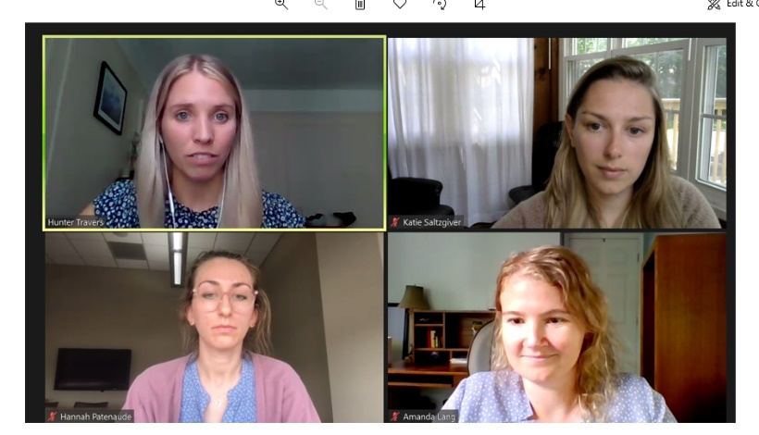**Webinar Overview**

* Our first jointly hosted webinar of the year and second annual rendition of an advocacy webinar hosted with WIN, the U.S. WIN x Nuclear Matters “Nuclear Outreach Webinar: Building Trust Online” event, garnered **123 attendees**, and our outreach to advocates received an **average open rate of 25.16% and click rate of 0.77%.**
* The webinar was recorded for people who were unable to attend and is accessible [here](https://apco.zoom.us/rec/share/Pd4XKB5RJKXoRpSREI9GZIGFb6anY2PLIJt9es9eACqhevawVv6iL_-xuVl6pXz3.Q_Aym3kloXu6sgQ9).

*Password: =9gLkU?D*

* Of our attendees, we saw representation from the **Energy Harbor, Exelon, Idaho National Laboratory, Oak Ridge National Laboratory, NuScale Power, PSEG, TVA** and **Westinghouse** teams.
* During the webinar, we saw **15+ questions submitted**, several comments and interactions in the chat, and a range of positive feedback from attendees expressing their appreciation for the topics covered.
* Following the webinar, we received outreach from multiple attendees, including from a professor at NC State and our friend Bill Temmink for feedback on their advocacy efforts and interest in expanding local pro-nuclear groups.

**Attendee Feedback:**

