[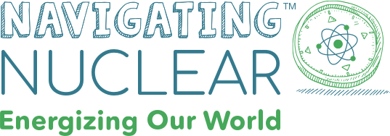](https://www.navigatingnuclear.com/about)

American Nuclear Society Center for Nuclear Science and Technology Information

&

Discovery Education

About

“**Navigating Nuclear: Energizing Our WorldTM** is an exciting new program from the American Nuclear Society and Discovery Education, designed to provide educators with FREE standards-aligned activities, lessons, career explorations, and project ideas to clarify common misconceptions surrounding nuclear science and explore its role in future technological applications.

The curriculum resources created for **Navigating Nuclear** have been reviewed by a national panel of independent educators. This panel has validated that all standards-aligned Elementary, Middle, and High school resources contained within this program examine multiple perspectives of the ways nuclear energy powers our world and also serves to build scientific literacy around nuclear processes and the vast impact nuclear processes have on energy, healthcare, agriculture and the global community.

**Navigating Nuclear: Energizing Our WorldTM** aims to increase awareness of the safe, effective, and efficient applications and contributions of nuclear science and technology by providing standards-aligned classroom resources for educators and students that explore the current, real-world applications of nuclear processes and their role in future advancements.”

Sign Up for Updates: <https://www.navigatingnuclear.com/about>

Resources

* [Explore Careers](https://www.navigatingnuclear.com/explore-careers)
  + Nuclear Researcher Bio’s
  + Career Profiles
  + Quotes & Photos
* [Virtual Field Trip](https://www.navigatingnuclear.com/nuclear-reimagined-vft)
  + Idaho National Laboratory
  + Isotopes, Reactors of Tomorrow, TRISO Fuel, Nuclear Careers, and more!
* [Elementary School Student Resources](https://www.navigatingnuclear.com/classroom-resources/elementary-school/)
  + STEM Project Starters
    - Each with two 50-60 minute classroom sessions
    - Evolving Energy Sources, Destination Deep Space, Powering Ocean Vessels
  + Educator Lesson Plans
    - 45 minutes of content
    - Amazing Atoms, Exploring Energy

“Guide your elementary school students through the world of nuclear energy with digital lesson plans, project starters, and more to power up the learning in your classroom!

Spark a reaction in your classroom with nuclear science! Start small by exploring an atom as the foundation for nuclear energy. Then, go big and learn how a star releases energy in the form of a nuclear reaction! Navigating Nuclear provides educators with standards-aligned resources to connect students to the many fact-based applications of nuclear energy. Students will use nuclear science principles to explore medicine, geology, energy, astronomy, space, and more!”