**Palo Verde Women in Nuclear - HERstory**

*Editor’s Note; Welcome to the Palo Verde Women in Nuclear (PV-WIN) special HERstory series commemorating Women’s History Month in March. Each week, a PV-WIN writer will contribute a story about women’s influential role in nuclear science. Enjoy the series and let us know what you think in the comments section below.*

*The Girls of Atomic City* depicts the untold story of several young ladies that were recruited at a very young age, to work on a secret “project.” The story is compelling enough on its own, but paired with the opportunity to learn how women, unbeknownst to them, made significant strides in the fields of science, is quite exhilarating.

At the cusp of World War II, Oak Ridge, a small town in Tennessee, was hidden in plain sight. In 1942, the United States government decided to build a city in the obstructed lands of Tennessee. It was to be the site of massive plants that would help build the secret weapon that the government hoped would speed the end of World War II. Several buildings were erected and in order to staff the large plants, recruiters were sent out across the eastern and southern parts of the country. As a result of the war, many men were off in the service and labor was in short supply. Women were on the home front, eager to do their part to end the war and became the obvious first choice.

Thousands of people would eventually work there, their feats covered in secrecy as they worked to produce something called “the product” that would be used in “the gadget.” Only a handful of people knew what was really going on: that the product was enriched uranium and the gadget was the first atomic bomb.

The stories told by those that were there, as captured in the book, are compelling. However, Jane Greer’s story, a statistician-mathematician from Paris, Tennessee is my personal favorite. Although she planned for an engineering degree from the University of Tennessee, she was unable to enroll in engineering on account of her gender. Instead, Jane graduated with a degree in business statistics in 1943. Upon graduation, she was offered a job as a statistician-mathematician. Her staff obtained data from the “calutron girls” and she calculated the percentage of uranium-235 obtained during the isotope separation process.

After the war, Jane remained in Oak Ridge and continued to use her statistics and mathematics experience to work at the X-10, a graphite reactor, which helped develop peacetime uses for atomic energy.

*Written by Mayra Alvarado, Senior Coordinator, Emergency Preparedness.*

**The Missileers**

*Editor’s Note: Welcome to the second installment of Palo Verde Women in Nuclear (PV-WiN) special HERstory series commemorating Women’s History Month in March.*

The Missileers — Air Force Nuclear and Missile Operations Officers — are the men and women dedicated to standing at the ready to launch the nation’s 450 nuclear-capable intercontinental ballistic missiles (ICBMs).

The Air Force has the highest female population of any branch of the military at approximately 20 percent. Making the one out of five Missileers who are women an elite group, a total of 247 women as of 2018.

In March 2016, the Air Force had enough women to schedule an all-female alert, or “pulling crew”. Pulling crew is a rotating 24-hour shift inside a capsule between 60-feet and 80-feet underground passing through two blast doors.

Much like many of us experience in our Nuclear Professional roles, the Missileers experience intense training and are expected to know and follow protocol. Day-to-day activities include a lot of maintenance and making sure the missiles are in operating condition.

These women are an influential part of nuclear science. While they did not discover or invent anything in particular, they are working daily as an important facet of our country’s nuclear infrastructure. Seeing a part of these ladies task load each day makes me want to pride myself even more as a Nuclear Professional at Palo Verde.

Written by Jamie McMichael, Analyst, Business Operations.

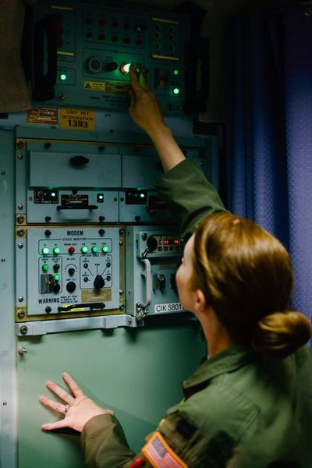

Captain Amber Moore adjusts one of the capsule's myriad communications systems, all of which with their floppy disks and landlines are from another era

**Lise Meitner**

*Editor’s note: Welcome to the third installment of Palo Verde Women in Nuclear (PV-WiN) special HERstory series commemorating Women’s History Month in March*

Throughout nuclear history, women have often taken on the roles of either scientists (Marie Curie, Berta Karlik) or victims (Radium girls, Calutron girls), but the woman largely responsible for the discovery of nuclear fission is a bit of both.

In late 1930’s Germany, Lise Meitner and Otto Hahn were working on the possibility of splitting atoms with heavy nuclei — a feat that physicists at the time believed impossible. Meitner fled Nazi Germany but took a position in Stockholm where she maintained a working relationship with Hahn and continued work on what would later become nuclear fission.

When it came time to publish their findings, Hahn felt that including a Jewish woman on the paper would cost him his career in Germany, so he published without her, citing his own insights for the discovery.

Since much of the work was based on Meitner’s knowledge, the paper fell short in explaining the actual mechanism of how the atoms had split. In response to the paper, Meitner and her nephew Otto Frisch sent a letter to an international scientific journal which detailed the mechanisms behind Hahn’s findings.

Unfortunately, the Nobel Prize was solely awarded to Hahn in 1944 “for the discovery of the fission of heavy nuclei”. Ironically, the term “fission” was not used in Hahn’s paper but had been coined in Meitner’s letter.

Although she was not acknowledged by the Nobel committee, Meitner received many other honors throughout her lifetime, empowered other women to take on STEM roles, and remained a positive force for women in the scientific community.

I encourage you to read more about Meitner’s contributions, which are detailed in the following article:

<https://theconversation.com/lise-meitner-the-forgotten-woman-of-nuclear-physics-who-deserved-a-nobel-prize-106220>

*Written by Lacey Mowery, IT Solutions Engineer/Analyst.*

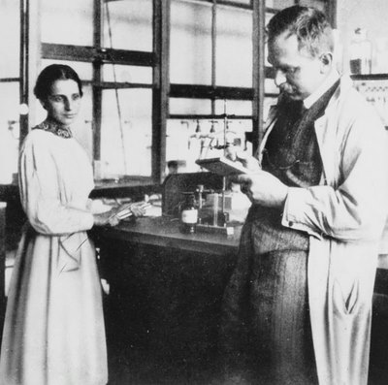Lise Meitner: a physicist who never lost her

positivity in the face of adversity.

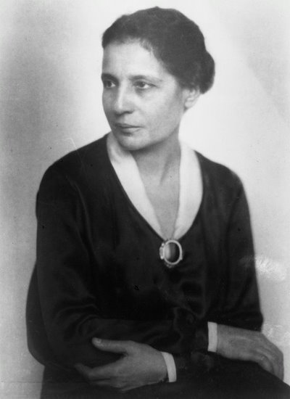 Source: Science History Institute.

Lise Meitner and Otto Hahn in their laboratory,

c. 1913. Source: World Nuclear Association,

Outline History of Nuclear Energy.

***Billie Garde, Esq.***

*Editor’s note” Welcome to the fourth installment of Palo Verde Women in Nuclear (PV-WiN) special HERstory series commemorating Women’s History Month in March.*

The 80s were a time most often remembered for its politics, style, technology and great pop culture. Many recall learning that Darth Vader was Luke's father and watching the final episode of M.A.S.H. The spectrum of fads ranged from shoulder pads, parachute pants and Rubik’s Cubes to the mullet, big hair bands and MTV, while new technology included the Walkman, Betamax and the start-up of Palo Verde Generating Station — the world’s first nuclear plant to utilize treated waste water as its source of cooling water.

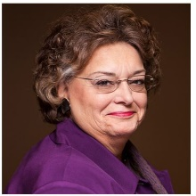But for Billie Garde, the 80s were anything but nostalgic. Her true to life “reality show” is a culmination of *Silkwood*, *The Insider* and *Erin Brockovich* and one that ultimately shaped the nuclear industry’s Safety Conscious Work Environment.

**Sex, Drugs and the U.S. Census Bureau**  
“For a good time call” was the implicit motto of the 1980 U.S. Census Bureau in Muskogee, Oklahoma and one that sent Billie Garde — a former high school teacher and single mother of two — down a rabbit hole that ultimately uncovered political corruption, sexual harassment, coercion of sexual favors, drug use and defrauding of the federal government.

Garde's story began when she was ordered by her boss, the Director of the Eastern Oklahoma Census Bureau — a man who had high political aspirations and was gunning for a congressional seat — to not only perform sexual favors with him and recruit her young former female students (under the guise of civil service) to use drugs and perform sexual favors with visiting government officials, but also falsify federal qualification test scores to get his favored applicants on the federal payroll.

When Garde refused to comply and blew the whistle, she was subjected to harassment, intimidation, and threats of interference with the custody of her children. After she was fired, and the allegations of her boss’s misconduct went public, she became the target of vandalism and then lost custody of her children without notice or reason.

Many of Garde’s claims of misconduct and intimidation were later substantiated by government investigators. Her boss — and others — were indicted on felony charges for conspiring to defraud the government, obstructing a criminal investigation and engaging in patronage hiring by using the census operation to promote his political aspirations. Ironically, the same day the Grand Jury indicted her boss, Garde’s children were returned to her.

**Pay It Forward -** *Changes that lead to a Safety Culture Work Environment*

Determined to lead change, Garde went to law school and joined the Government Accountability Project (GAP), the public interest group that her helped prosecute her whistleblower claims and regain custody of her daughters.

“Championing the right cause doesn’t require years of experience or advanced degrees,” states Garde, “it just takes heart and the will to pay it forward.”

Over the last 35 years, paying it forward has been Garde’s mission. She started investigating worker allegations at the Zimmer and Midland nuclear construction sites; but in 1983, when a group of Electrical Quality Control (QC) inspectors marched into work at the Comanche Peak construction site wearing black t-shirts that read “Comanche Peak Nitpickers – We’re in the Business of Picking Nits,” her work took a surprising turn.

The QC protest was a reaction by inspectors after being told by management to stop being such “nitpickers”. After management learned of the t-shirt protest, orders were issued for on-site Security Officers, along with drug-sniffing dogs, to find and detain the protestors. The workers were chased across site. Some hid, while others changed out and hid their protest shirts. Eventually Security detained the majority of the inspectors against their will in a single guarded room, but not before one worker secretly called Billie Garde for assistance.

While still in her first year of law school, Garde represented the nitpickers and other whistleblowers before the Comanche Peak Atomic Safety Licensing Hearing. Because of the sheer number of safety related complaints, the NRC would not grant Comanche Peak’s license without further investigation so Garde, still a law student, and other lawyers took nearly 100 depositions to determine if retaliation had impacted the quality of work during construction. Because all of the local hotels were full with high-profile attorneys representing Comanche Peak and the NRC, Garde and her two daughters lived in a tree house throughout the summer while taking depositions.

While “the nitpickers” story became legendary, conscientious workers from nuclear plants across the country started raising even more concerns. Unfortunately, the issues were raised at a time when Safety Conscious Work Environment regulatory expectations were non-existent. Companies often attacked the workers by claiming they were disgruntled, anti-nuclear exaggerators, or liars and retaliated against them in an unprecedented manner.

* Zimmer Nuclear Power Plant. Worker concerns were in the thousands and given the sheer volume resulted in Congressional Oversight Hearings. Unfortunately, the workers who testified were retaliated against even further, and doused with buckets of urine and feces. Upon learning of the incidents, the NRC shut down all construction activities. Eventually, the cost to repair the worker identified issues — from shoddy steel, concrete voids to unverifiable weld inspections — became untenable and construction of the Zimmer Plant was abandoned.
* Midland Nuclear Power Plant. After numerous concerns were raised about the falsification of weld inspector qualifications throughout construction, the individual who provided substantiating documentation to the NRC, was terminated. Seventeen years after construction commenced, Midland Nuclear, citing numerous construction problems, converted the plant to natural gas.
* TVA’s Watts Bar. Upon informing the NRC of regulatory noncompliance issues, three managers were removed from their positions and given “do nothing” jobs.

Too many concerns were proven to be valid and required extensive and costly repairs. In some cases, like Zimmer and Midland, the costs were just too much, while other plants continued on but at an extraordinarily inflated budget. Comanche Peak, for example, exceeded estimates by $6 billion. Adding insult to injury, the NRC, which had no program in place to manage or address concerns, lost credibility for failing to address claims or protect whistleblowers and became the subject of Congressional Oversight Hearings and negative press.

“These are just a few examples of how the owners and construction companies failed to address the technical, quality and other types of significant concerns brought forward by workers,” claims Garde.

“All too often, management response was a hodgepodge of denials, attacking the concerned individuals by questioning their motives or calling them anti-nuclear and allowing them to be subjected to harassment and retaliation by taking away their duties or terminating them,” she continued. “And because the NRC had no programs in place to address employee concerns, the workers sought protection from public interest groups like GAP.”

In an attempt to manage thousands of employee concerns, Garde, along with other nuclear professionals, helped design programs to capture, catalogue and address issues. But the success — or failure — of the programs were determined by the cooperation and support of the individual utilities. Some executives recognized the value of employee concerns and chose to investigate them, while others never did.

In 1988, NEI and TVA sponsored a workshop for all nuclear plants to address the “whistleblower phenomena.”  At the time, Garde was representing whistleblowers across the country, including workers from nuclear plants under construction, plants in operation, contractors and the NRC.

Although Garde was considered “Public Enemy Number One,” she was asked to speak at the forum and to date, continues to speak at conferences and utilities throughout the industry. Employee Concerns Programs are now a critical part of any nuclear utility’s oversight and compliance programs across the country.

Despite her own bitter experience, Billie Garde evolved from whistleblower to an advocate for whistleblowers and a champion for Safety Conscious Work Environment training programs.

“A positive Safety Culture is the best deterrent for unacceptable risks and consequences,” stated Garde during the five-hour training she presented to Palo Verde leaders.

*Written by Tammera Baker, Consultant, Leadership Development.*