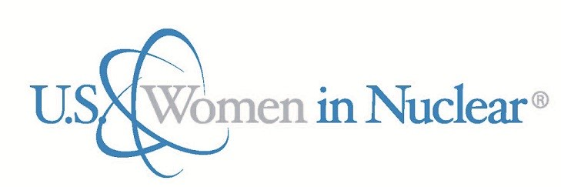U.S. WIN Champion Award

Award Process

In celebration of advocates who support and empower women to achieve their professional goals, the US Women in Nuclear organization is pleased to announce the call for nominations for the U.S. WIN Champion Award. This award is intended to celebrate individuals who openly support and empower women to achieve their professional goals. This award recognizes an individual who serves as a strong advocate, mentor, collaborator, and sponsor of women in the nuclear industry.

Nomination Criteria: Nominees should have demonstrated results in the following areas:
- Actively contributes to the advancement and development of women either inside or outside his/her own organization and publicly celebrates the work and accomplishments of females
- Supports the development of women and empowers them to engage and leverage their influence
- Promotes education, career development, and mentorship for women in his/her organization
- Supports initiatives or programs that enable development and advancement of women in the industry

Nomination Process: Any active U.S. WIN member may recommend a candidate for consideration. All recommendations must be seconded by an active U.S. WIN member.

Documentation Submittals: New nominations must include completion of the current year Nomination Form – U.S. WIN Champion Award and a letter of recommendation. Nominations submitted in any of the three (3) previous years will be considered during the evaluation process providing a current year Nomination Form – U.S. WIN Champion Award is received by the committee prior to the due date.

Nomination Acceptance: Nominations and supporting documents will be accepted through March 15th of the current calendar year for the next calendar year award.

Evaluation Criteria: Nominations will be evaluated based on the nomination form and supporting informational documents submitted. Nominations will be evaluated based on the award eligibility criteria and how the champion's advocate for women in their company and the impact of the advocacy on their colleagues has had positive result on the Women in Nuclear organization.

Evaluation Process: The U.S. WIN Awards & Recognition Committee will screen all applicable nominations. Following the evaluation process, a recommendation for a single recipient will be provided to the U.S. WIN Steering Committee for consensus affirmation.

The Awards and Recognition Champion subcommittee consists of up to ten representatives including one from each of the four U.S. WIN Regions; the U.S. WIN Steering Committee, Committee Executive Sponsor (SC-CES); the previous year’s honoree, and the Chair of the Steering Committee or designee. The recipient selection process will be completed by April 30th of the award year. The honoree and company (if applicable) will be notified in April by the Awards & Recognition Committee or the Steering Committee.

*Please note, this award is conferred at the discretion of the U.S. WIN Awards & Recognition Committee.

Award Presentation: The U.S. WIN Champion Award will be announced and presented at the U.S. WIN National Conference.

