U.S. WIN Professional Development Webinar Registration Announcement

**"** **Write It So They Read It:**

**Instantly Effective Email Tips To Get Your Messages Opened, Read and Acted Upon"**

**Mandi Stanley**

May 30, 2018; 2:00 - 3:30 p.m. EDT

To register for the webinar, Follow this [Link](https://www.surveymonkey.com/r/2CR85QY)

(<https://www.surveymonkey.com/r/2CR85QY>)

The webinar will be hosted by INPO.  Only 200 call lines are available, and the PD Committee encourages U.S. WIN members to meet as chapters or in groups to participate in the webinar.  **Please register by close of business on May 25, 2018.  Call in instructions will be provided to registered participants May 29, 2018.**

It's true. You're writing internal management memos and sending emails—and no one is reading them. You're emailing important updates and attaching detailed reports, but it quickly becomes evident no one has read the email or even opened the attachment. They received it, but they didn't read it. That's a problem—and a huge time waster.

The webinar will cover:

* The BLUF technique for getting to the point
* FAVORITE TOPIC: Where to use *bulleted lists* in emails to maximize your message
* The top seven credibility-robbing email mistakes and how to avoid them
* The importance of a complete email subject line—and how to write one consistently every time
* How to obliterate sloppy, lazy, lax emails—because email lasts forever
* How to get a grip on your inbox with a few time management tips
* How to make sure your e-messages are absolutely error free with no embarrassing typos or mistakes

With more than 22 years of experience on the seminar circuit, Certified Speaking Professional Mandi Stanley works primarily with technical specialists who want to boost their professional image by becoming better speakers and writers. She’s the award-winning business author of ***The No-Panic Plan for Presenters: An A-to-Z Checklist for Speaking Confidently and Compellingly Anywhere, Anytime.*** Audiences appreciate her platform enthusiasm, interactive style, and content-rich messages.

Graciously Sponsored by:

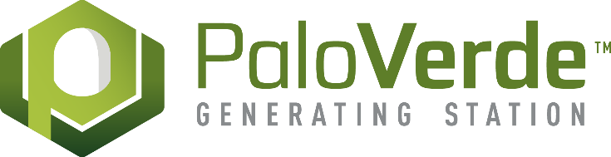 Dominion Energy Logo

Please email the U.S. WIN PD Committee at [ProfDvmt@winus.org](mailto:ProfDvmt@winus.org) if you have any questions.